Biobe nstallation instructions into frame
Installation of VS ventilator into milled airchannel
Biobe ventilator and filter are fastened by 2 screws, on top of the airchannel milled into the windowframe. Filter unit is mounted under the ventilator. Canopy is fastened on top of the airchannel to the outer of window, with 2-3 screws depending on the length. Upper edge of the canopy is seamed watertight.

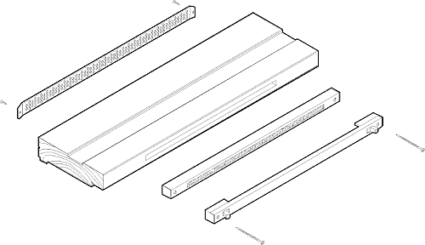
Installation of VS ventilator into drilled airchannel
Drilled airchannel is used in projects where ventilators are mounted afterwards and where there are no milled airchannels in a window frame. Airchannel is made by drilling a row of 10 mm holes into the upper part of a window frame. Biobe ventilator and filter are fastened by 2 screws, on top of the holes. Filter unit is mounted under the ventilator. Canopy is fastened on top of the holes to the outer side of window, with 2-3 screws depending on the length. Upper edge of canopy should be seamed watertight.
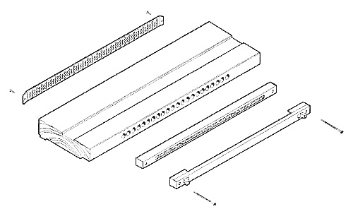

Installation of VS ventilator into oakum gap
Biobe ventilator can also be mounted into the gap between window frame and wall structure. In this mounting option a plastic airchannel is used in the gap. It connects ventilator and canopy. This air channel should be tightened on it´s place with mineralwool or polyurethan. Biobe ventilator and filter are fastened by 2 screws on top of the hole made into the list covering the gap. The type of canopy may vary depending on the wall construction.
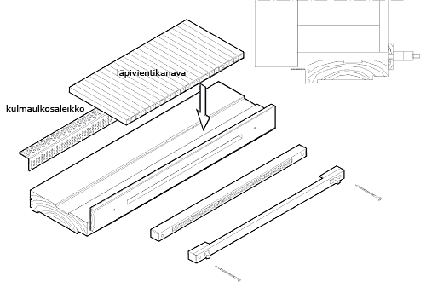

corner canopy and plastic air channel

Notice while mounting
With Biobe slot ventilator always use Biobe canopy. If an other brand is used then be ensure that there is an sufficient air flow into the ventilator. In any care air channel should always be protected from rain water with a canopy.

2xH45130
Dimensions for Biobe –ventilator / filter
Ventilator | Length mm | Height mm | Depth mm  ventilator | Depth mm  with filter
Biobe 20 | 295 | 18 | 20 | 40
Biobe 30 | 395 | 18 | 20 | 40
Biobe 40 | 495 | 18 | 20 | 40
Biobe 50 | 595 | 18 | 20 | 40
Biobe 60 | 695 | 18 | 20 | 40

Mounting dimensions for Biobe –compensation air ventilator
Ventilator | Hole to be milled / mm | Holes to be drilled
Biobe 20 | 12x200 | 14 kpl 10 mm Ø
Biobe 30 | 12x300 | 22 kpl 10 mm Ø
Biobe 40 | 12x400 | 29 kpl 10 mm Ø
Biobe 50 | 12x500 | 36 kpl 10 mm Ø
Biobe 60 | 12x600 | 44 kpl 10 mm Ø

Biobe vertical ventilator XS-P
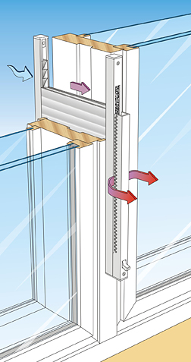
Biobe vertical ventilator XS-P is ventilator to be mounted into window frame or oakum gap. It is suitable both for new construction and renovation.

With Biobe ventilator the incoming air flow can be controlled in gravital and mechanical ventilation and ensure sufficient fresh air into the rooms. Incoming air can be calculated as per room and department.

Filter unit reduces impurity of incoming air. direct the compensation air to the both sides of ventilator. Complete Biobe XS-P ventilator consists ventilator, filter unit and canopy.

Material
Ventilator, filterbody and canopy are made of weather-proof aluminium. Filter is made of foamed plastic. There is no coldbridge between the canopy and the ventilator which decreases the risk of freezing during cold temperatures.

Colors
white (RAL 9010)
anodized brown ~RR32)
other colors as special order (RAL color map)

Silencing capasity of Biobe air ventilator XS-B (VTT RTE4035/01)
Ventilator | Dn,e,w+C (dB) | Dn,e,w+Ctr (dB)
Biobe 30 | 34 | 34
Biobe 40 | 33 | 33
Biobe 50 | 31 | 31
Biobe 60 | 30 | 30

Biobe vertical ventilator with milled hole, no silencer (VTT RTE 4035/01)
Ventilator | Air channel (mm) | l/s (5 Pa) | l/s (10 Pa) | l/s (20 pa)
Biobe 30 | 12x300 | 2,2 | 3,3 | 5,0
Biobe 40 | 12x400 | 2,8 | 4,3 | 6,4
Biobe 50 | 12x500 | 3,5 | 5,3 | 8,0
Biobe 60 | 12x600 | 4,0 | 6,0 | 9,0
Biobe 60+H60130 | 12x600 | 3,2 | 4,8 | 7,3

Order info
Biobe vertical ventilator product code
Biobe X30 vertical ventilator
Biobe X40 vertical ventilator
Biobe X50 vertical ventilator
Biobe X60 vertical ventilator
Biobe S30 filter
Biobe S40 filter
Biobe S50 filter
Biobe S60 filter
Biobe P30 vertical canopy
Biobe P40 vertical canopy
Biobe P50 vertical canopy
Biobe P60 vertical canopy

Material aluminium/foamed plastic
Surface treatment/ A anized aluminium RR21
Color R brown RAL 8019
V white RAL 9010
other colors are special order (RAL color map)
Min quantity order as agreed

Inlet channel as extra accessory (see equipment). Silencer available also for both milled and drilled airchannel.

Installation instructions

Installation to a milled airchannel
Biobe ventilator and filter are fastened by 2 screws, on top of the airchannel milled into the windowframe. Filter unit is mounted under the ventilator. Canopy is fastened on top of the airchannel to the outside of window drop edge pointing downwards with screws. Upper edge of the canopy is recommended to be seamed watertight.
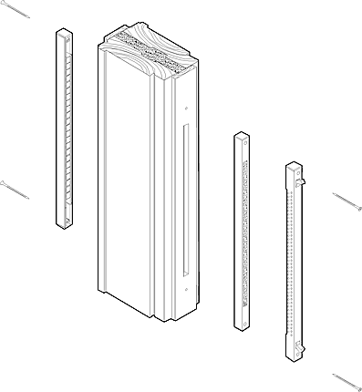

window with two frames

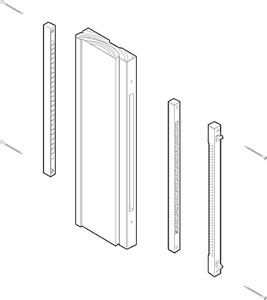
window with one frame

Installation to a drilled airchannel
Drilled air channel is used in projects where ventilators are mounted afterwards and where there is no milled air channel in a window frame. Air channel is made by drilling a row of 10 mm holes into the window frame. Biobe ventilator and filter are fastened by 2 screws, on top of the holes drilled into the vertical part of the window frame. Filter unit is mounted under the ventilator. Canopy is fastened on top of the holes to the outside of window as drop edge pointing downwards, with screws. Upper edge of canopy is suggested to be seamed watertight.

Installation into oakum gap
Biobe ventilator can also be mounted into the gap between window frame and wall structure. In this mounting option a plastic air channel is used in the gap. It connects ventilator and canopy. This air channel should be tightened on it´s place with mineralwool or polyurethan. Biobe ventilator and filter are fastened by two screws on top of the hole made into the list covering the gap.
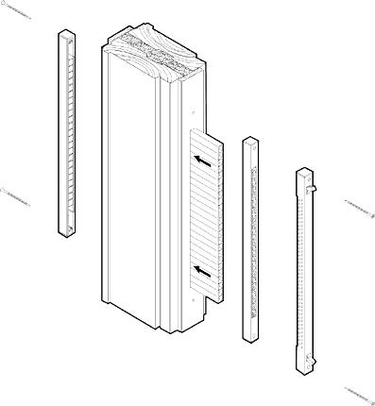
installation into oakum gap
Notice while mounting
With Biobe slot ventilator always use Biobe canopy. If other option is used, then be ensured that there is sufficient air flow into the ventilator. Air channel should also be protected from rain.
Biobe vertical ventilator
Ventilator | Lenght (mm) | Height (mm) | Depth (mm)
Biobe 30 | 395 | 18 | 20
Biobe 40 | 495 | 18 | 20
Biobe 50 | 585 | 18 | 20
Biobe 60 | 695 | 18 | 20

Air channel | Milled hole (mm) | Drilled holes
Biobe 30 | 12 x 300 | 22 pcs x 10 mm Ø
Biobe 40 | 12 x 400 | 29 pcs x 10 mm Ø
Biobe 50 | 12 x 500 | 36 pcs x 10 mm Ø
Biobe 60 | 12 x 600 | 44 pcs x 10 mm Ø

